











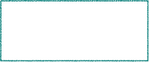
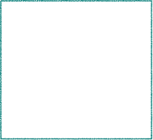
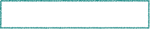
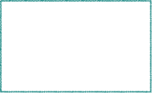

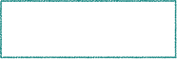



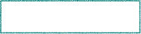


Basic Program Structure
void setup() { }// Runs once
void loop() { }// Runs repeatedly
{} curly braces: define the beginning and end of function / statement blocks
; semicolon: end statements and separate elements (i.e. in a for loop).
Functions
Control Structures
if (condition) {...} else {...}
for (int i = 0; i < 10; i++) {...}
while (condition) {...}
do {...} while (condition);
switch (var) { //must be integral not float
case 1:
…… ; break;
default:
…… ;
}
goto; label // AVOID!
continue; // Go to next iteration
return x; // or “return;” for voids
Advanced I/O
tone(pin, frequency_hZ, {duration_ms})
noTone(pin)
pulseIn(pin, value, {timeout})
pulseInLong(pin, value, {timeout})
pin/value(HIGH|LOW)/ms-default 1sec)
shiftIn(dataPin, clockPin, bitOrder)
shiftOut(dataPin, clockPin, bitOrder)
input/toggle/(MSBFIRST|LSBFIRST)
Boolean Operators
&& and|| or! not
Pointer Access Operators
& reference operator - get a pointer
If x is a variable, then &x represents the address of the variable x
* dereference operator - follow a pointer
If p is a pointer, then *p represents the value contained in the address pointed by p.
int *p; // declare a pointer to an int data type
int i = 5;
int result = 0;
p = &i; // now 'p' contains the address of 'i'
result = *p;
// 'result' gets the value at the address
// pointed by 'p'
// i.e., it gets the value of 'i' which is 5

Pointers are one of them more compicated topics, but they are handy to have in one’s toolkit.
Compound Operators
+=addition-=subtraction++increment
/=division*= multiplication--decrement
%=remainder
^=bitwise xor&=bitwise and|=bitwise or
Bitwise Operators
& bitwise and bitwise or^ bitwise xor
~ bitwise not<< shift left >> shift right
Arithmetic Operators
+ add - subtract/ divide
* multiply = assignment% modulo
Digital I/O
digitalRead(pin)
digitalWrite(pin, value(HIGH|LOW))
pinMode(pin,mode) INPUT|OUTPUT|INPUT_PULLUP

Analog I/O
analogRead(pin)
analogWrite(pin, value)
value: the duty cycle: between 0 (always off)
and 255 (always on). Allowed data types: int
analogReference(type) Configures the reference voltage: See doc for type

Zero, Due & MKR Family
analogReadResolution(bits) (1-12*)
analogWriteResolution(bits)
Comparison Operators
== (equal to) != (not equal to)
< (less than) > (greater than)
<= (less than or equal to) >= (greater than or equal to)
Further Syntax
#defineGive a name to a constant value before compilation. -> No PROGMEM required. Localizes “Magic Numbers”.
#include(include)
/* */block comment
//single line comment
Characters[myChar = variable (int only)]
isAlpha(myChar)isAlphaNumeric(myChar)
isAscii(myChar)isControl(myChar)
isDigit(myChar)isGraph(myChar)
isLowerCase(myChar)isUpperCase(myChar)
isPunct(myChar)isSpace(myChar)
isPrintable(myChar)isWhitespace(myChar)
isHexadecimalDigit(myChar)
Math
abs(x)max(x, y)min(x, y)
sqrt(x)sq(x)pow(base, exponent)
constrain(x, minrange, maxrange)
map(val, fromL, fromH, toL, toH)

Trigonometry
sin(rad)cos(rad)tan(rad)
Bits and Bytes
bit(n)bitRead(x,n) bitWrite(x,n,b)
bitSet(x,n)bitClear(x,n)
highByte(v)lowByte(v)
x: the numeric variable v: value of any type
n: which bit, starting at 0 for the least-significant (rightmost) bit 7 for the most-significant (leftmost)
b: the value to write to the bit (0 or 1)
Time
delay(ms)
delayMicroseconds(us) // 16383 Max
micros() // both return runtime since
millis() // program started running
// resolution varies per board type
CommunicationUSB
Serial Keyboard
Stream Mouse
Constants
Predefined expressions used to make the programs easier to read.HIGH | LOWtrue | false
INPUT | OUTPUTINPUT_PULLUPLED_BUILTIN

Suffix: long | unsigned | float
65536L | -1U | 3.0F
Exponential form4.2e1
Prefix: octal, hexadecimal 0 | 0x or 0X
Character constants: char | octal | hex
‘a' |’\ooo' |'\xhh'
newline | cr | tab | backspace
\n | \r | \t | \b
Special characters\\, \?, \', \”
Variables
Conversion
byte(x) char(x)float(x)
int(x)long(x)word(h,l)
x: a value of any type
h: the high-order (leftmost) byte of word
l: the low-order (rightmost) byte of word
Casting:
Utilities
PROGMEM // put my info into flash memory, instead of SRAM
sizeof(variable) // The number of bytes in a variable, or bytes occupied in an array. size_t is the usual return type
Variable Scope & Qualifiers
const // make a variable "read-only"
scope // any variable declared outside of a function (e.g.setup(), loop(), etc.), is a global variable.
static // persistant variables visable to only one function
volatile // used in code associated with interrupts (ISR)
Structure
Interupts: interrupts() noInterrupts()
Interrupts are useful for making things happen automatically in microcontroller programs

void loop() {
noInterrupts();
// critical, time-sensitive code here
interrupts();
// other code here
} // Example:insure that a program always catches the pulses from a rotary encoder, so that it never misses a pulse.

External Interrupts: (recommended options)
attachInterrupt(
digitalPinToInterrupt(pin),ISR,mode);
detachInterrupt(digitalPinToInterupt(pin));
Random Numbers
random() // Pseudo Random Numbers
randomSeed() // Init. PRN Generator
Arduino Coding Cheat Sheetv11
compiled by Paul Ciarelli
Functions (ANSI)
return_type function_name( parameter list ) {
function body
} // return_type is ‘void’ if nothing is returned.
Structure




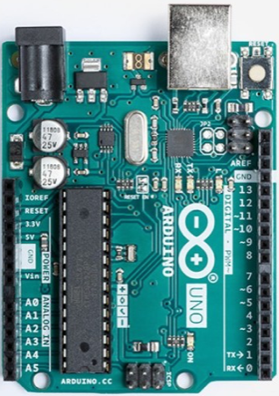





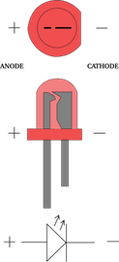
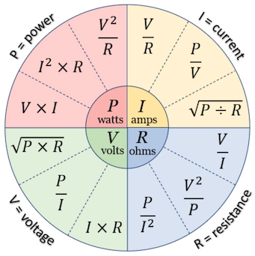

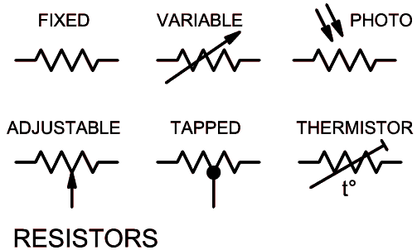
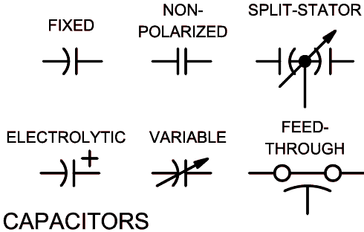
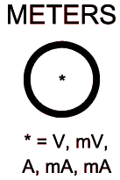
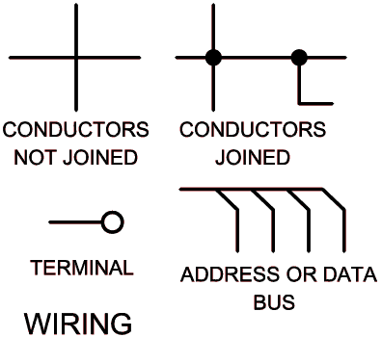
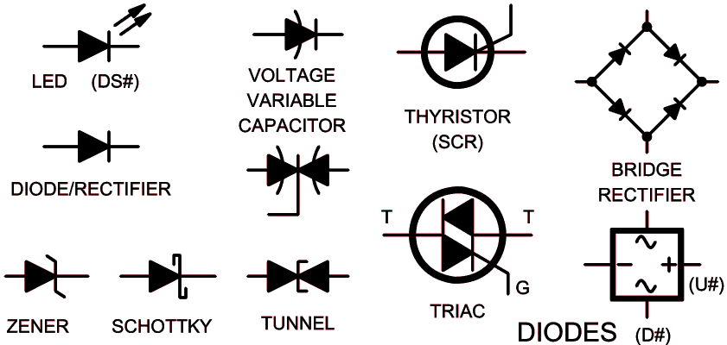
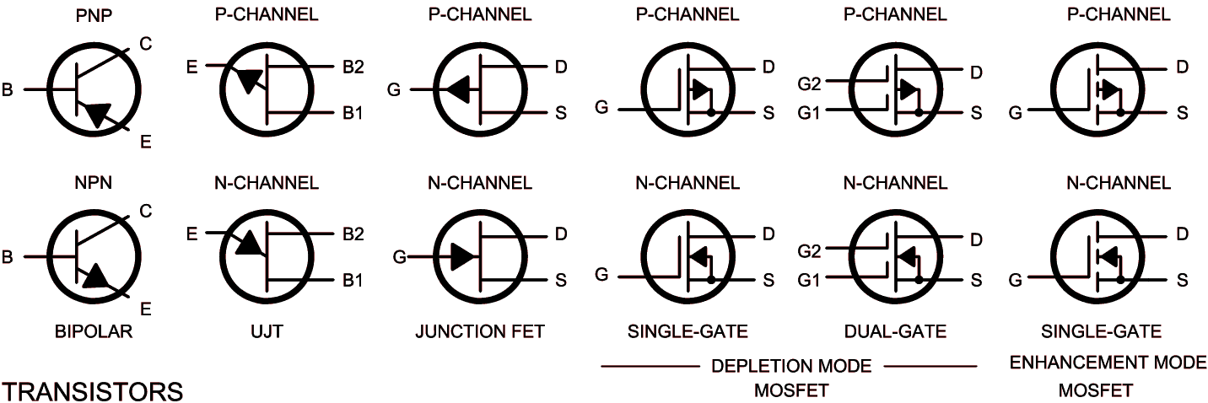
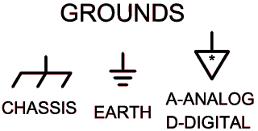
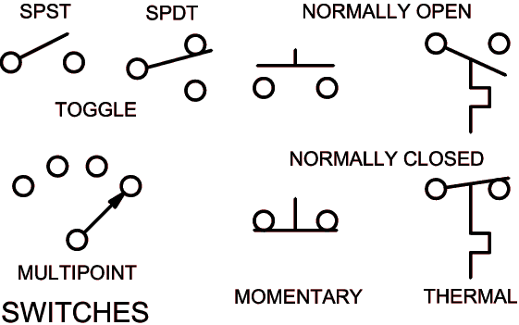
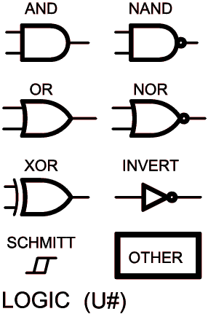

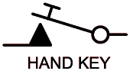

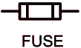

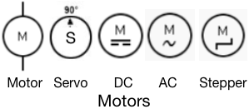
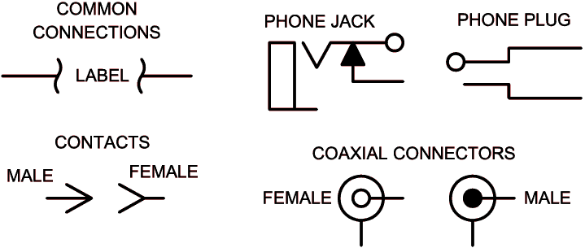
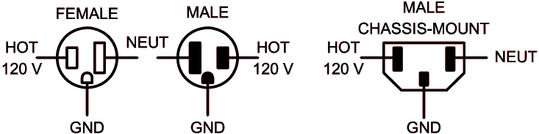
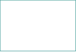


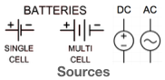
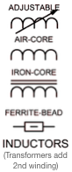
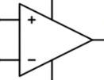



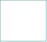

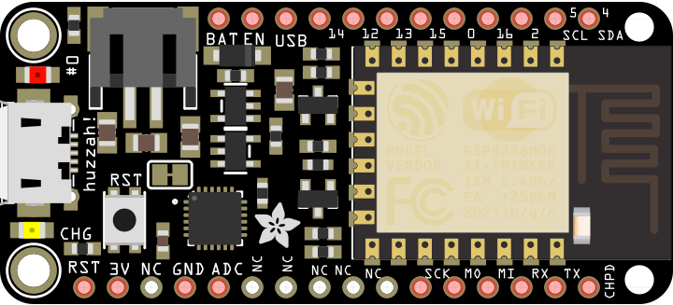
C Coding Style Guide
MUD: ...Here's How to write Clean Code
Whatever style you use, be Consistant!
KISS - Keep it Simple, Silly
Use Parenthesis, etc, even when you don’t have to.
Use whitespace - use spaces and indentation, the compiler dosn’t care. How to change default Tab behavior at the bottom of this discussion https://forum.arduino.cc/index.php?topic=111859.0
Comments - if you are explaning it to yourself, explanin it to everyone.
Meaningful identifiers.
( very subjective/ may change)
common/trivial variables - lower case
local variables camelCase
global variables - g_lower case (avoid)
constants and macros- All Caps
private functions - TitleCase
public functions - camel_Case with underscores
DRY - Don’t repeat yourself! Use Functions/encapsulate repeated tasks.
Functions should do precisely one thing only.
Explicit is better than implicit. Don’t use language features that let you hide the obvious.
Limit line length to 80 Characters.
If the width of a int matters, use C99's portable fixed-width integer types. i.e. int8_t.
Initialize variables as soon as you know the initial value.
Avoide Magic Numbers. Declare constants using static const or enum. #define sometimes.
Use #IF Make the compiler help you enforce limits.
Minimize Global Variables.

Arduino Uno R3 (From: Components 101)

32KB Flash(.5BL) 2KB SRAM, 1KB EEPROM at 16MHz
Operating Voltage 5V
Input Voltage Limits 6-20V / 7-12 Recommended
DC Current on I/O Pins40mA DC Current on 3.3V Pins 30Ma
Coding Tips
F() Macro: stores strings in flash instead of SRAM ex: Serial.println(F(“I’m stored in flash”));
C ternary operator ?: Make code more readable:
The expression x ? y : z evaluates to y if the value of x is true, otherwise to z
Standard Libraries
EEPROM - reading and writing to "permanent" storage
Ethernet - for connecting to the internet using the Arduino Ethernet Shield, Arduino Ethernet Shield 2 and Arduino Leonardo ETH
Firmata - for communicating with applications on the computer using a standard serial protocol.
GSM - for connecting to a GSM/GRPS network with the GSM shield.
LiquidCrystal - for controlling liquid crystal displays (LCDs)
SD - for reading and writing SD cards
Servo - for controlling servo motors
SPI - for communicating with devices using the Serial Peripheral Interface (SPI) Bus
SoftwareSerial - for serial communication on any digital pins. Version 1.0 and later of Arduino incorporate Mikal Hart's NewSoftSerial library as SoftwareSerial.
Stepper - for controlling stepper motors
TFT - for drawing text , images, and shapes on the Arduino TFT screen
WiFi - for connecting to the internet using the Arduino WiFi shield
Wire - Two Wire Interface (TWI/I2C) for sending and receiving data over a net of devices or sensors.

Library Lists
https://www.arduinolibraries.info/libraries
https://www.arduinolibraries.info/libraries
https://circuitpython.readthedocs.io/en/3.x/docs/
drivers.html
Thanks to: Compiled by Paul Ciarelli
arduino.cc, Sicuramente Adafruit, Ever helpful!
Nick Parlante: Essential C / Pointers and Memory
Gavin Smith, Mark Liffiton, et al. Design
Raph Levien: Inconsolata font Leeward Business Advisors
C Operator Precedence
Op Amp
Adafruit Feather HUZZAH with ESP8266
Arduino Data Types
Data Types | B | Min Size | Max Size
char | 1 | -128 | 127
unsigned char | 1 | 0 | 255
bool | 1 | true|false | 1|0
boolean1 |  | Non standard. Just use bool
byte | 1 | 0 | 255
int (UNO) | 2 | -32768 | 32767
unsigned int | 2 | 0 | 65535
short1 | 2 | -32768 | 32767
long | 4 | -2147483648 | 2147483647
unsigned long | 4 | 0 | 4294967295
float | 4 | -3.4028E+38 | 3.4028E+38
double1 | 4 | Implemented the same as float 6-7 digits of precision only!
string
String()1 |  | C++ Strings: more functionality at the cost of more memory
array
size_t |  | Capable of representing the size of any object in bytes
void
1 - not typically used in A-IDE
C99’s Portable Fixed Width Interger Types
Gives integer types archit​ect​ure​-in​dep​endent lengths.
int8_t | 1 | -128 | 127
uint8_t | 1 | 0 | 255
int16_t | 2 | -32768 | 32767
uint16_t | 2 | 0 | 65535
int32_t | 4 | -2147483648 | 2147483647
uint32_t | 4 | 0 | 4294967295
Arrays [Data Type] // INDEX STARTS AT 0
int myInts[6];
// not initialized (OK)
int myPins[] = {2, 4, 8, 3, 6};
// (auto sized by compiler)
int mySensVals[6] = {2, 4, -8, 3, 2};
// both inialized and sized
char message[6] = “hello";
// one more element than length of string is required
mySensVals[0] = 10; // Assignment
x = mySensVals[4]; // Retrieval

Array in for loop:
int i;
for (i = 0; i < 5; i = i + 1) {
Serial.println(myPins[i]);
}
Factor | 10x | Prefix | Symbol
1,000,000,000 | 109 | giga | G
1,000,000 | 106 | mega | M
1,000 | 103 | kilo | k
100 | 102 | hecto | h
10 | 101 | deka | da
0.1 | 10-1 | deci | d
0.01 | 10-2 | centi | c
0.001 | 10-3 | milli | m
0.000001 | 10-6 | micro | µ
0.000000001 | 10-9 | nano | n
0.000000000001 | 10-12 | pico | p
Pin Category | Details
Power | Vin: Input voltage using an external power source.  5V: Regulated power supply used to power microcontroller and other components  3.3V: 3.3V supply generated by on-board voltage regulator. Maximum current draw is 50mA.  GND: ground pins.
Reset | Resets the Microcontroller
Analog Pins | A0 – A5 - Provide analog input in the range of 0-5V
I/O Pins | Digital Pins 0 - 13 - input or output pins.
Serial | 0(Rx), 1(Tx) Receive and transmit TTL serial Data
Ext. Interupts | 2.3 To trigger an interrupt.
PWM | 3, 5, 6, 9, 11 - Provides 8-bit PWM output.
SPI | 10 (SS), 11 (MOSI), 12 (MISO), 13 (SCK) - SPI comm.
Inbuilt LED | 13 - To turn on the inbuilt LED.
TWI | A4 (SDA), A5 (SCA) - Used for TWI communication.
AREF | AREF - Provide reference voltage for input voltage.
Lvl | Details
1 | () []→.(dot)
2 | ! ~ ++ -- +(unary)  -(unary) *(deref)  &(address of) (cast) sizeof
3 | *(multiplication) / %
4 | + (binary) - (binary)
5 | << >>
6 | < <= > >=
7 | == !=
8 | & (bitwise AND)
9 | ^
10 | |
11 | &&
12 | ||
13 | ?:
14 | = += -= *= /= %= &= ^= |= <<= >>=
15 | , (comma)

